NS112
KEYLOCK SWITCH

DESCRIPTIONS:  - Zinc alloy die cast housing and cylinder.  - Bright chrome plated standard  - No pin tumbler mechanism.  - Zinc alloy tubular keys, chrome plated.  - Key withdrawals in both positions only.  - Silver plated contacts and terminals.  - 2 position (off-on) 2 terminals.  - Hex nut mounted.  - 1 combination only.  KEY-PULL FIGURES  -Off Position  -Indicates Key-Pull  -Indicates No Key-Pull  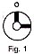 | 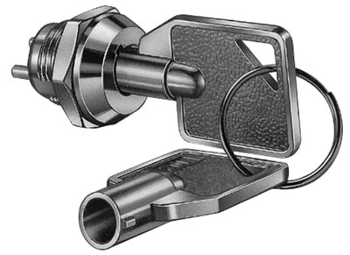

Fig. No. | Lock Number | Pole | Positions | Terminals | Key Pulls | Turn |  |  | Type
1 | NS112-2 | 1 | 2 | 2 | 2 | 90  | Off | On | SPST

