窗体顶端
 | PDF Files
  ME060-381 | PDF Files
  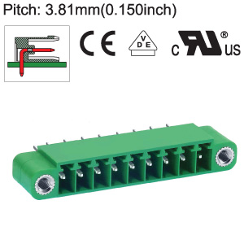
  - Description :
  - Pitch : 3.81 mm (0.150 inch)
  